TITLE PAGE

**Table of Contents**

Abstract 1

Introduction 1

Chapter 1 Overview on X-ray detection 1

1.1 Sources of characteristic X-rays 1

1.1.1 Excitation by radioactive decay 1

1.1.2 Excitation by external radiation 1

1.1.3 Synchrotron radiation 2

1.2 Interaction mechanisms of X-rays with matter 2

1.2.1 Photoelectric absorption 3

1.2.2 Compton scattering 3

1.2.3 Coherent scattering 4

1.2.4 Pair production 4

1.3 Electromagnetic radiation absorbed dose 5

1.4 Solid state X-ray detectors 5

Chapter 2 Overview on materials 8

Chapter 3 Experimental Methods 8

3.1 MoS2 Samples 8

3.1.1 Fabrication methods 8

3.1.2 IV characterization 8

3.1.3 Characterization under X-rays 8

3.2 TMTES:PS Samples 8

3.2.1 Fabrication methods 8

3.2.2 IV characterization 8

3.2.3 Characterization under X-rays 8

Chapter 4 Results for MoS2 samples 8

Chapter 5 Results for TMTES:PS samples 8

Chapter 6 Conclusions 8

Bibliography 8

# Abstract

Here is the abstract…

# Introduction

This is the Introduction part. Here I include the topic of the thesis, brief description of innovative materials, the goal of the thesis – to understand and to compare two performances of the devices with similar structures, the structure of the thesis.

# Overview on X-ray detection

Here I discuss the general X-ray detectors, thin-film transistors for X-ray detection. Don’t be too long here.//

## Sources of characteristic X-rays

If the orbital electrons in an atom are disrupted from their normal configuration by some excitation process, the atom may exist in an excited state for a relatively short period of time. Eventually, there is a natural tendency for the orbital electrons to rearrange themselves to return the atom to its lowest energy state (ground state) within a time which is characteristically in the range of nanoseconds for a solid material. The energy liberated in the transition from the excited state to the ground state takes the form of a *characteristic X-ray photon* whose energy is defined as the difference between the initial and the final states of the atom (Knoll, 2010).

A large number of different physical processes can lead to the population of excited atomic states from which characteristic X-rays originate. The most common mechanisms include:

### Excitation by radioactive decay

In the nuclear decay process of electron capture, the nuclear charge is decreased by the capture of an orbital electron, most often a *K*-electron. The resulting atom still has the right number of electrons, but the capture process also creates a vacancy in one of the inner shells. Once this vacancy is subsequently filled, characteristic X-rays are generated (Knoll, 2010).

### Excitation by external radiation

This method involves an external source of radiation (X-rays, electrons, α-particles etc.) which strikes the target, creating excited or ionized atoms in the target. Since many of these atoms eventually de-excite to the ground state through the emission of characteristic X-rays, the target can serve as a localized source of these X-rays.

As an example, the incident radiation may consist of X-rays generated in a conventional X-ray tube. The external X-rays may then interact with the atoms of a target through photoelectric absorption; therefore, the excited atoms will emit characteristic X-rays creating their X-ray spectrum. This process is called *X-ray fluorescence*.

Another example of incident radiation could be an external electron beam. In this case the characteristic X-ray spectrum from the target will be contaminated by the continuous *bremsstrahlung* spectrum generated by the deceleration of impinging electrons by their interaction with atomic nuclei. For targets of low atomic number, acceleration potentials of only a few thousand volts are required, which allows to use compact electron sources.

The excitation of a target can also be due to heavy charged particles. The interactions of these particles with the target will give rise to the excited atoms, which will subsequently emit characteristic X-rays. For compact and portable sources, α-particles are often used as incident radiation. As α-particle emitters, 210Po and 244Cm are commonly used (Knoll, 2010).

### Synchrotron radiation

Another source of X-rays is performed, when an electron beam is bent into a circular orbit. According to the electromagnetic theory, a fraction of the beam energy is released when the trajectory of the electrons is deflected within a cycle. When extracted from the accelerator in a tangential direction, the radiation appears as an intense and highly directional beam of photons with the energy ranging from visible light (~eV) to X-rays (~104 eV). Although limited to large-scale centralized user facilities, this unique form of electromagnetic radiation is highly because of its high intensity and tunable radiation energy (Knoll, 2010).

## Interaction mechanisms of X-rays with matter

Although a large number of interactions mechanisms between electromagnetic radiation and matter are known, the three major types are usually taken into consideration:

* Photoelectric absorption
* Compton scattering
* Pair production

The common feature of these interactions is partial or complete transfer of the photon energy to an orbital electron, which results in abrupt disappearance of an impinging photon or change of its trajectory by scattering on the electron (Knoll, 2010).

### Photoelectric absorption

In the photoelectric absorption process, a photon interacts with an absorber atom, in which the photon passes its energy to an orbital electron and disappears. Instead, an energetic *photoelectron* is ejected by the atom from one of its bound shells. The photoelectron energy is calculated according to the energy conservation law:

|  |  |
| --- | --- |
| $$E_{e^{-}}=hν- E_{b}$$ | 1.1 |

where *Eb* is the binding energy of the photoelectron in its original shell. In addition to the photoelectron, the photoelectron absorption also generates an ionized absorber atom with a vacancy in one of its shells. This vacancy is quickly filled through capture of a free electron or rearrangement of electrons from the other shells. As a result, one or more characteristic X-ray photons may be generated. In most cases these X-rays are reabsorbed close to the original site through photoelectric absorption involving less tightly bound shells. However, their possible escape from radiation detectors can influence their response. In some fraction of the cases, the emission of an Auger electron may substitute fir the characteristic X-ray in carrying away the atomic excitation energy.

The photoelectric absorption process is the predominant type of interaction for X-rays (and gamma-rays) of relatively low energy. The process is also enhanced for absorber materials of high atomic number *Z*. Although there is no single analytic expression for the probability of photoelectric absorption per atom over all ranges of photon energy *­­Eγ* and *Z*, its rough approximation is present:

|  |  |
| --- | --- |
| $$τ ≅const × \frac{Z^{n}}{E_{γ}^{3.5}}$$ where *n* varies between 4 and 5 over gamma-ray energy region (Knoll, 2010). | 1.2 |

### Compton scattering

In Compton scattering, the incoming X-ray (or gamma-ray) photon is deflected through an angle *θ* with respect to its original direction (Fig.1) by its interaction with an electron in an absorber atom. The photon transfers a portion of its energy to the electron (assumed to be initially at rest), which is then as a *recoil electron*. Since any angle of scattering is possible, the energy transferred to the electron can vary from zero to a large fraction of the impinging photon energy (Knoll, 2010).

The expression that relates the energy transfer and the scattering angle can be derived by combining the energy and momentum conservation laws:

|  |  |
| --- | --- |
| $$hν^{'}= \frac{hν}{1+ \frac{hν}{m_{0}c^{2}}\left(1-\cos{θ}\right)}$$ | 1.3 |

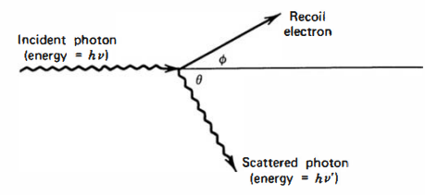

Figure 1.1 Schematic representation of the Compton scattering process (Knoll, 2010).

where *m0c2* is the rest mass energy of the electron (0.511 MeV). The probability of Compton scattering per atom depends on the number of electrons availble as scattering targets and thus, increases linearly with *Z* (Knoll, 2010).

### Coherent scattering

In addition to Compton scattering, another type of scattering can occur, when an X-ray (or gamma-ray) photon interacts coherently with all the electrons in an absorber atom. Such *coherent scattering* or *Rayleigh scattering* process neither excites nor ionizes the atom and the scattered photon retains its original energy, although its direction is changed. The probability of Rayleigh scattering is significant only for low photon energies (usually below a few hundred keV for common materials) and in high-*Z* absorbers. Since the average deflection angle decreases with increasing energy, the practical importance of coherent scattering is restricted to low photon energies (Knoll, 2010).

### Pair production

If the gamma-ray energy exceeds twice the rest-mass energy of an electron ( $E_{γ}≥1.02$ MeV), the process of pair production becomes energetically possible. In this interaction (which must take place in the Coulomb field of the nucleus), the gamma-ray photon disappears generating an electron-positron pair. All the excess energy goes into kinetic energy shared by the positron and the electron. Since the positron will subsequently annihilate after slowing down in the absorbing medium, two annihilation photons are normally produced as secondary products of the interaction. No precise expression exists for the probability of pair per nucleus, but its magnitude varies approximately as the square of the absorber atomic number (Knoll, 2010).

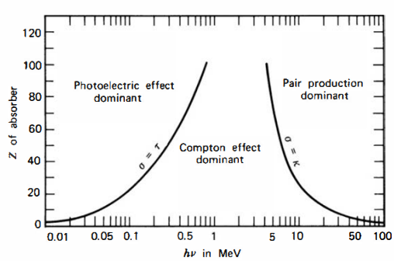

Figure 1.2 Schematic representation of relative probability for different interaction types to occur depending on the *Z* of an absorber atom and on the photon energy *hν*. The lines illustrate the values of *hν* for which the two neighbouring effects are equally probable (Knoll, 2010).

## Electromagnetic radiation absorbed dose

The mean absorbed radiation energy per unit mass of the absorber is the *absorbed dose*. The SI unit of absorbed dose is defined as *gray* (Gy) which is 1 joule per kilogram. The absorbed dose is a reasonable measure of the chemical or physical effects created by a given radiation exposure in an absorbing material (Knoll, 2010).

## Solid state X-ray detectors

The whole multitude of X-ray detection devices might be unified by the principle of creation of charges (free electrons and ions) by passing of X-rays through a material. The most commonly used examples are gas ionization chambers, scintillation counters and semiconductor-based detectors. While the first two types have quite complex configuration, the semiconductor-based devices provide outstanding combination of compact size, high speed, spatial resolution and sensitivity []. The use of semiconductor materials as radiation detectors can result in a much larger number of carriers for a given incident radiation event that is possible for any other common detector type. The fundamental information carriers are *electron-hole* pairs created by a charged particle or a photon (as primary radiation or its secondary products) in the detector. The motion of generated electrons and holes in an applied electric field generates the basic electrical signal from the semiconductor detector (Knoll, 2010).

Devices employing semiconductors as the basic detection medium became practically available in the 1960s. Early versions were called *crystal counters*, but modern detectors are referred as *semiconductor diode detectors* or *solid-state detectors*. In addition to superior energy resolution, semiconductor solid-state detectors have other advantageous features, such as compact size, relatively fast timing characteristics and effective thickness that could be varied depending on the application requirements. Drawbacks of solid-state detectors may include the relatively high susceptibility of the devices to perform degradation by radiation-induced damage (Knoll, 2010).

The radiation solid-state detectors described in this section are based on the *pn*-junction properties. Once the *n*- and *p*-type regions are brought together in contact, charge carriers become able to migrate across the junction. In order to avoid gaps between regions, a *pn*-junction is normally produced in a single crystal by changing the doping conditions at the different sides of the junction.

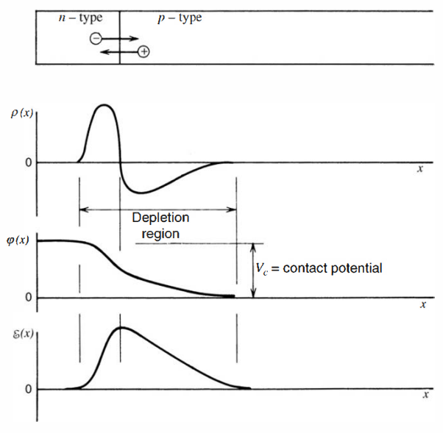

Figure 1.3 The behavior of the charge density *ρ(x)*, electric potential *φ(x)* and electric field *ε(x)* across a *pn*-junction (Knoll, 2010).

The approximate variation of equilibrium charge density is plotted in Fig.Figure 1.3 The behavior of the charge density *ρ(x)*, electric potential *φ(x)* and electric field *ε(x)* across a *pn*-junction (Knoll, 2010)(Knoll, 2010). In the *n*-region, the density of electrons is much higher than in the *p*-region. Therefore, the junction between two regions represents a discontinuity in the conduction electron density. Wherever such a sharp charge gradient exists for any carrier which is free to migrate, a net diffusion from a region with high concentration to the region with low concentration occurs. Consequently, a fraction of conduction electrons will diffuse to the *p*-region, where they will recombine with holes. The diffusion of conduction electrons from the *n*-region to the ­*p*-region will leave behind immobile positively charged donor ions which will form positive space charge at the junction on the *n*-type side.

A similar process occurs with holes in the *p*-region. Due to their high concentration gradient at the junction, a fraction of holes will diffuse from the *p*-region to the *n­*-region. Each hole that migrate from the *p*-region, will leave behind an acceptor atom that has picked up an extra electron and therefore represents a fixed and immobile negative charge which generates negative space charge at the junction on the *p*-type side.

As a result, the accumulated space charge creates an electric field that reduces the tendency for subsequent diffusion of the chargers across the junction establishing a steady-state charge distribution. The region over which non-zero charge distribution exists is called the *depletion region* and extends into both the *p*- and *n*-type sides of the junction. The depletion region possesses quite attractive properties as a radiation detection tool. The electric field across the ­*pn*-junction causes any conduction electrons or holes in the depletion region to be swept to the *n-* or *p-*sides, respectively. The region is thus “depleted” in that the concentration of electrons and holes is quite small. The only charges remaining in the depletion region are the immobile donor and acceptor ions. Similarly, any electron-hole pairs created in the depletion region by the passage of a radiation, will be swept by the electric field, so that their motion will create an electric signal.

The thermal generation of charge carriers will continue to take place in the depletion region, contributing to the leakage current. However, these charges are swept away typically within nanoseconds, a time which is many orders of magnitude shorter than the time required to establish thermal equilibrium. Therefore, the steady-state concentration of thermal charge carriers will stay minuscule, making it possible to detect small concentration of charges created by ionizing radiation to be detected CITATION Gle10 \l 1033 (Knoll, 2010).

Although the working principle of solid-state X-ray detectors is the same – formation of electron-hole pairs, the methods of conversion of X-ray radiation to electrical signal can be categorized into two groups: *direct* and *indirect* conversion. Direct conversion detectors are based on semiconductor materials, in which the incident X-ray photons produce electron and hole charge carriers, which then drift towards the device electrodes under an applied electric field []. Alternatively, indirect conversion detectors are based on scintillating films (e.g. CsI) which convert incident X-ray photons into visible light that is detected by photodiodes.

In the next paragraphs I will discuss some examples of the solid-state X-ray detectors that are widely used in physics and medical applications.

Pn junction

Materials used in x ray detectors

Configurations

* **Reverse biased diode (used in Strip and 3D detectors)**

As mentioned above, even without external bias, a *pn*-junction creates a depletion region due to diffusion of electrons and holes across the junction. Such device can already serve as a radiation detector, since electron-hole pairs created in the space charge region will be separated by the built-in electric field creating a current across the junction. Reverse biasing can be used to increase the space charge region and therefore the total electric field. Reverse biased diodes have been already employed as energy sensitive radiation detectors in Nuclear Physics, but the real breakthrough came with strip detectors used for particle tracking with micrometer accuracy. Such strip detectors consist of numerous strip-like diodes integrated on the same wafer and each one connected to its own readout channel (Fig.1.4).The ionizing particle position is given by the channel which outputs the signal CITATION Chr20 \l 1033 (Christian W. Fabjan, 2020).

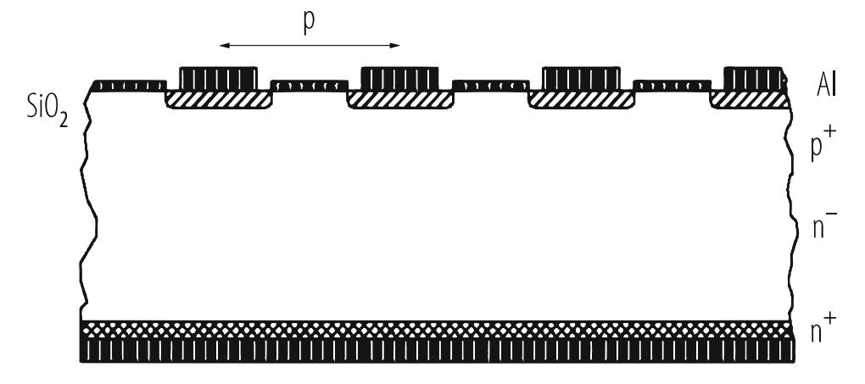

Figure 1.4 Cross section of a Si strip detector built on lightly P-doped (*n-*) silicon bulk material. Strips are highly B-doped (*p+*) and the backside is highly P-doped (*n+*). (Christian W. Fabjan, 2020)

A different concept of diode detectors is represented by so called 3D detectors (FIG>). In these devices columns with diameters of a few micrometers are etched into the crystal orthogonal to its surface, then alternate holes are *n+*- and *p+*- doped. A voltage difference between the *n+*- and *p+*- doped columns generates an electric field parallel to the crystal surface. The number of electron-hole pairs produced by a charge particle impinging on the detector is given by the crystal thickness, while the charge collection distance is given by the column distance. Therefore, signal and charge collection distances can be optimized for radiation tolerance. Besides, the operating voltage for 3D detectors is significantly reduced compared to planar detectors. By connecting the *n+*- and *p+*-columns with different metal patterns, strip- and pixel-sensors and other readout geometries can be obtained CITATION Chr20 \l 1033 (Christian W. Fabjan, 2020).

* **Semiconductor drift chamber**

Interaction of X-rays with matter

Semiconductor based X-ray detection principle (e-h pairs)

Examples of semiconductor-based X-ray detectors (direct detectors)

Field ef

# Overview on materials

Here I discuss the semiconducting materials for the active channel: MoS­2 and TMTES:PS.

# Experimental Methods

## MoS2 Samples

### Fabrication methods

### IV characterization

### Characterization under X-rays

## TMTES:PS Samples

### Fabrication methods

### IV characterization

### Characterization under X-rays

# Results for MoS2­ samples

# Results for TMTES:PS samples

# Conclusions

# Bibliography

BIBLIOGRAPHYChristian W. Fabjan, H. S. (2020). *Particle Physics Reference Library, Volume 2: Detectors for Particles and Radiation.* Vienna, Austria: Springer.

Knoll, G. F. (2010). *Radiation detection and measurement; 4th ed.* New York, NY: Wiley.